**Assignment 02**

**QUESTIONS:**

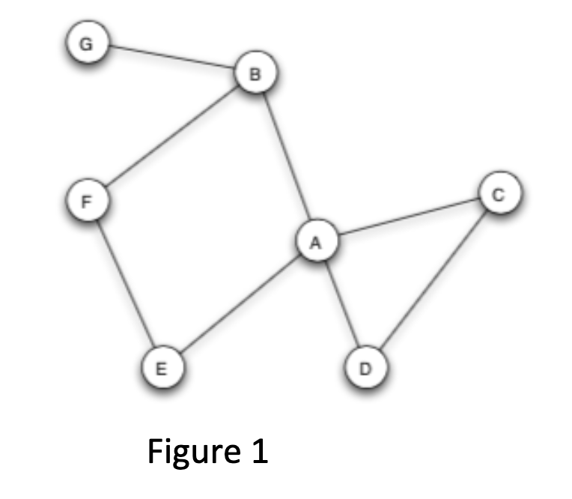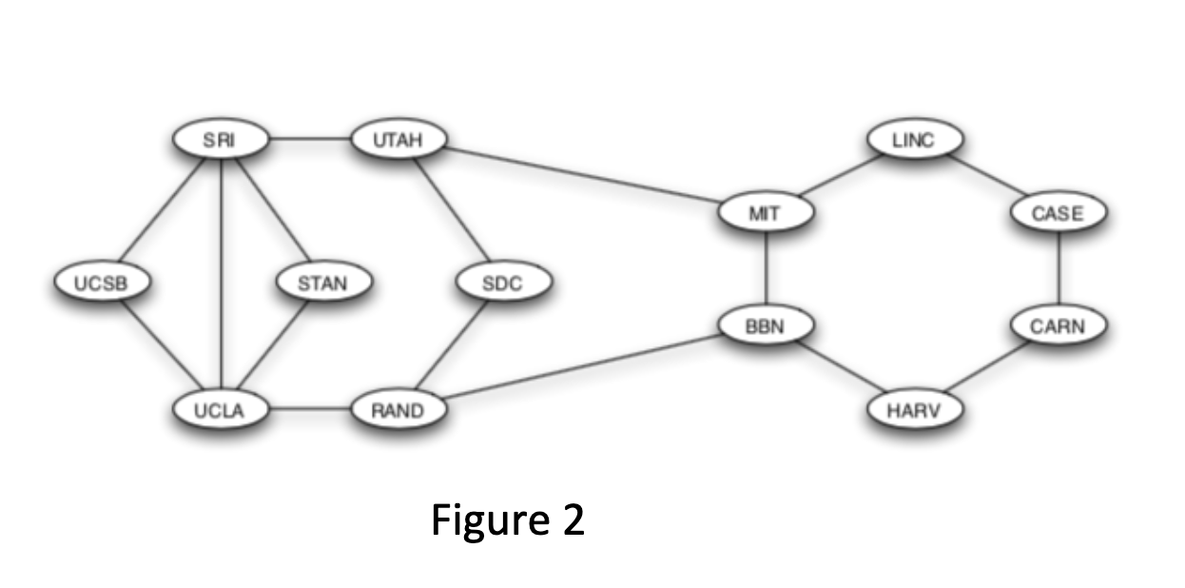

**1. a. Give an example of a graph in which every node is pivotal for at least one pair of nodes.**

**b. Explain your answer**.

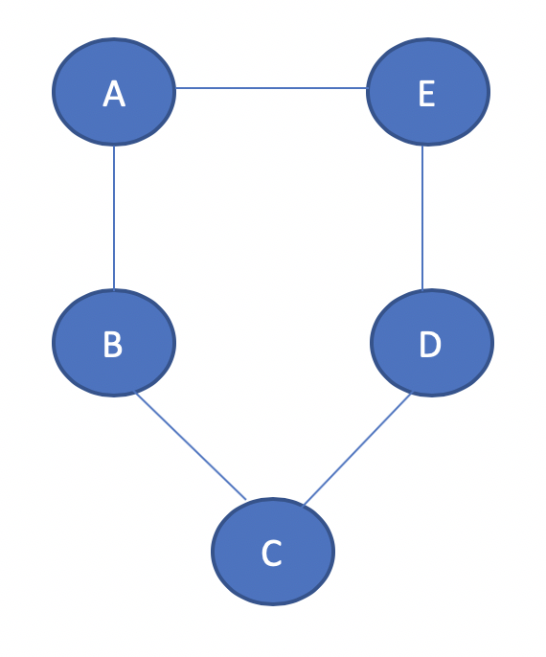

Above graph is an example, where each node is pivotal for the pair of its right and left neighbor nodes. In general, any circle with size n>4 will be an example of such graph, where n is the total number of nodes.

**2. a. Give an example of a graph having at least four nodes in which there is a single node X that is pivotal for every pair of nodes (not counting pairs that include X).**

**b. Explain your answer.**

Below graph is an example of a graph consists of five nodes and center node is a single pivotal node for every pair of nodes because for any path between two vertices, one must pass through the center.

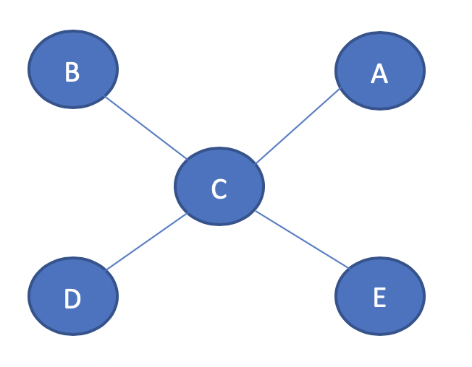

In general, any star network with size n > 3 will be an example of such graph, where n is the total number of nodes.

**3.a. Which node or nodes in Figure 1 are pivotal?**

**b. Explain your answer.**

In Figure 1, nodes A and B are pivotal nodes. Node A is pivotal for many pairs: the pair consisting of B and D because node A lies on every shortest path between B and D. Likewise node A is pivotal for the pair consisting of E and C, the pair consisting of E and C, E and D, G and C etc.

Node B is pivotal for pairs: the pair consisting of F and G, A and G, C and G etc. because node B lies on every shortest path between the nodes as described in pairs.

**4. a. Which node or nodes in Figure 2 are NOT pivotal?**

**b. Explain your answer.**

In Figure 2, UCSB and STAN nodes are not pivotal because there is no pair of nodes for which, nodes UCSB or STAN lie on every shorts path between that pair.

**5. a. Which node or nodes in Figure 1 are gatekeepers?**

**b. Explain your answer.**

Nodes A and B are gatekeepers. Node A is a gatekeeper because it lies on every path from B to C, B to D, E to C, E to D, G to C etc.

Node B is a gatekeeper since it lies on every path from F to G, A to G, C to G etc.

**6.a. Which node or nodes in Figure 1 are NOT local gatekeepers?**

**b. Explain your answer**

Nodes C, D and G are not local gatekeepers because there are no two nodes that are only connected by any one of C, D or G nodes.

**7.You will notice that there are no gatekeepers in Figure 2 (Darpanet). Explain why the network was purposely designed that way.**

The purpose of the network in Figure 2 is to reduce pressures of conforming to norms of different groups and to abstain any particular node accessing more ideas and information than any other.

**8.In your own words: In 2-3 sentences, explain what triadic closure is, and how it plays a role in the formation of social networks. You can draw a schematic picture in case this is useful.**

**Triadic Closure:** It can be defined as in a social network, if two people have any friends in common than in future, there is a greater chance that these two people will become friends. Let’s take a below example where Ram and Sita have common friend Lina.

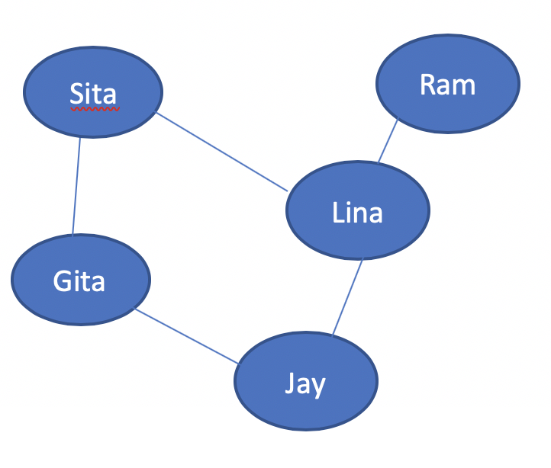

So, as per triadic closure, Sita and Ram can become friends in future at some point as they both have common friend named Lina. Thus, triadic closure plays an important role in formation of social networks.

**9.Consider the graph to the right, in which every edge but one is labeled as a strong tie (S) or weak tie (W).**

**a. According to the theory of strong and weak ties, with the strong triadic closure assumption, how would you expect the edge connecting b and c to be labeled?**

**b. Explain your answer.**

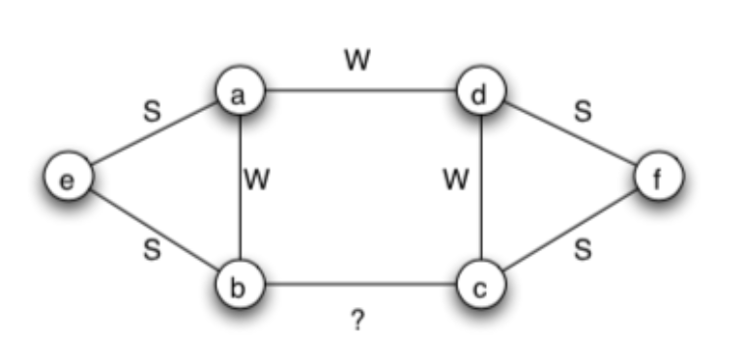

According to strong triadic closure assumption, the edge connecting b and c would be labeled as a **weak tie w** because if BC will be a strong tie, nodes B and C both violate Strong Triadic Closure Property as there is no edge between nodes e and c; b and f respectively (either a strong or weak).

**10.Consider the graph to the right, in which every edge is labeled as a strong tie (S) or weak tie (W).**

**a. According to the theory of strong and weak ties, with the strong triadic closure assumption, which other link or links would you expect to form over time, assuming that the links formed have strong ties? (consider more than one iteration over time and identify all links that should form)**

**b. Explain your answer.(continued on next page)**

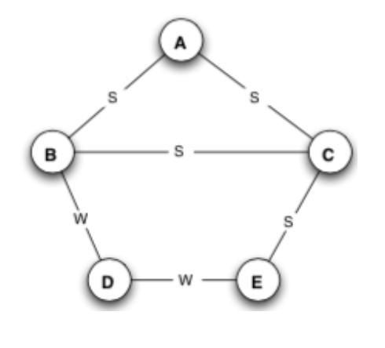

According to the theory of strong and weak ties, with the strong triadic closure assumption, in 1st iteration, I would expect to form AE link as strong tie because links AC and CE are labeled as strong ties.

In 2nd iteration, I. would expect to from BE link as strong ties because links BA and AE are connected as strong ties.

**11.Consider the affiliation network to the right, with six people labeled A–F , and three foci labeled X, Y , and Z.**

**a. Draw the derived network on just the six, joining two people when they share a focus.**

**b. In the resulting network on people, can you identify a sense in which the triangle on the nodes A, C, and E has a qualitatively different meaning than the other triangles that appear in the network? Explain your answer.**

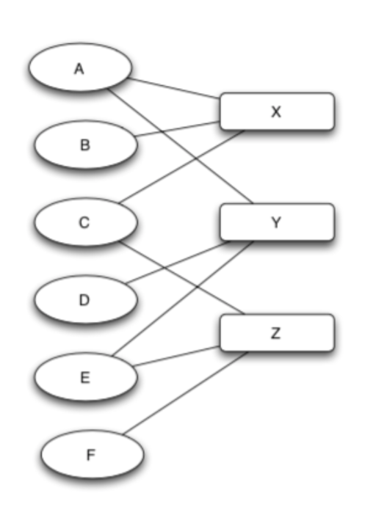

1. Below is the derived network on just the six, joining two people when they share a focus.

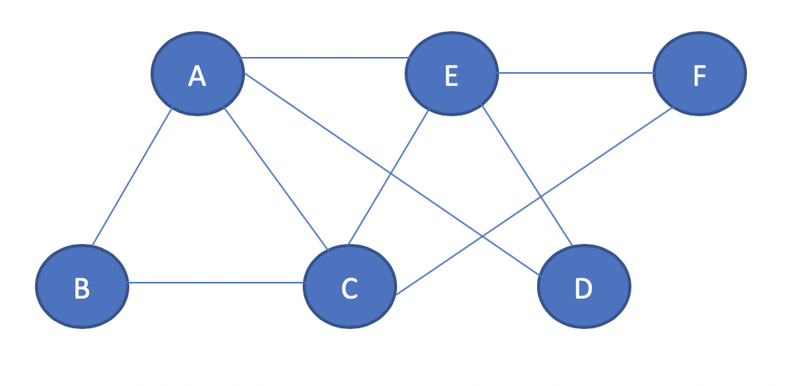

1. In above graph, as we can see the triangles ABC, ADE and CEF, in which, nodes in each triangle share a same focus whereas the triangle on the nodes A, C, and E is different because the nodes A, C and E do not share a same focus. There are three relations among the nodes A, C, and E. Thus, it is not. Necessary that all nodes in triangle share the same focus in corresponding affiliation network.

**12. A team of anthropologists is studying a set of three small villages that neighbor one another. Each village has 30 people. Everyone in each village knows all the people in their own village, as well as the people in the other villages. When the anthropologists build the social network on the people in all three villages taken together, they find that each person is friends with all the other people in their own village, and enemies with everyone in the two other villages. This gives them a network of90 people (i.e., 30 in each village), with positive and negative signs on its edges.**

**a. According to the definitions in chapter 5, is this network on 90 people balanced?**

**b. Explain your answer.**

Below is a graph, where V1, V2 and V3 are three villages consisting of 30 people, in which each person is friends with all the other people in their own village.

-

-

-

Here, all people in one village are enemies with all people in other villages. So, all three villages are connecting with negative edge and according to the definitions in chapter 5, if the triangle graph has all three negative edges, the graph is unbalanced. So, the given network of 90 people is **Unbalanced.**

We know for graph to be balanced, either all nodes should be friends (i.e. positive edges) or all nodes can be divided into two groups X and Y, where every pair of nodes in X and Y like each other (positive edge) and everyone in X is the enemy of everyone in Y (negative edge).

**13.In the network to the right, there is an edge between each pair of nodes, with five of the edges corresponding to positive relationships, and the other five of the edges corresponding to negative relationships. Each edge in this network participates in three triangles.**

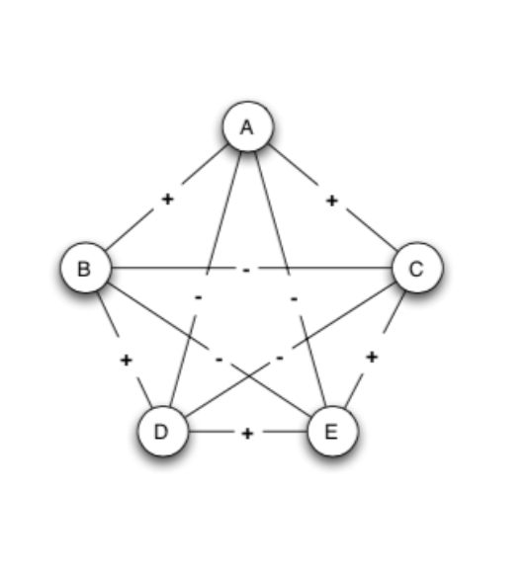

**a. For each of the 10 edges, list the following:**

* **The edge identification (i.e. AB)**

AB, AC, AD, AE, BC, BD, BE, DE, DC, EC

* **Whether the edge is positive or negative**

AB 🡪 Positive edge, AC 🡪 Positive edge,

AD 🡪 Negative edge, AE 🡪 Negative edge,

BC 🡪 Negative edge, BD 🡪 Positive edge,

BE 🡪 Negative edge, DE🡪 Positive edge,

DC 🡪 Negative edge, EC 🡪 Positive edge.

* **The three triangles the edge participates in**

*Representation form: -* **Edge**: Three Triangles the edge participates in

**AB**: ABD, ABE, ABC **AC**: ABC, ACE, ACD

**AD**: ABD, ACD, ADE **AE**: ADE, ACE, ABE

**BC**: ABC, BCD, BCE **BD**: BCD, BDE, ABD

**BE**: BDE, BCE, ABE **DE**: BDE, ADE, CDE

**DC**: CDE, ADE, BDE EC: CDE, BCE, ACE

* **The number of those triangles that are balanced and the number that are unbalanced**

**(Notice that because of the symmetry of the network, the balanced/unbalanced numbers will be the same for each positive edge, and also for each negative edge; so once you figure it out for one of each, you will have the answer for the others like it.)**

**Balanced triangles**: ADE, ABE, ACD, BCD, BCE

**Unbalanced triangles**: ABD, ACE, BDE, CDE, ABC